**LLM (Large Language Model)**

Research & Reported By Duaa Pirzada

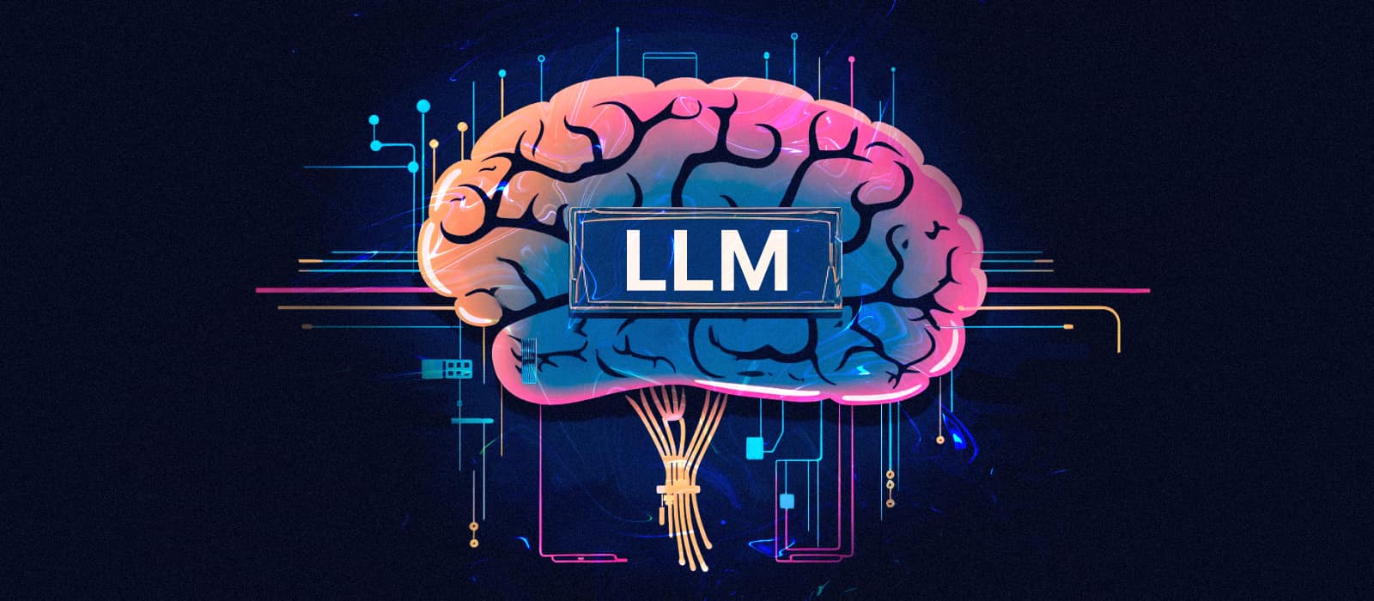

# What is LLM?

***“An LLM is a type of artificial intelligence (AI) design to understand, generate and process human language. It is trained on a massive amounts of text data to perform tasks like answering questions, writing texts, translating languages or even coding. Think of it as a super-smart chatbot that can mimic human like conversations or produce coherent text based on what it’s learned.”***

In simple terms, an LLM is like a giant library of words, sentences, and patterns that the AI uses to “think” and respond. It predicts the next word or phrase based on the context of what’s been said or written, making it seem like it understands you.

**Example:**

#### 1. Planning a cozy day:

“Grab a fluffy blanket and make a pillow fort! Pretend it’s a magical castle where you’re the ruler of Snuggleland. Sip hot cocoa with extra marshmallows, read a fairy tale, or draw pictures of happy clouds. Bonus: invite your pet or a stuffed animal to be your royal advisor! ☕🧸”

#### ****2. Cooking Biryani:****

If you say, “Tell me how to make biryani,” it’ll give you a recipe because it’s learned about cooking from all the data it’s seen.

### How Does an LLM Work?

An LLM is built using a neural network, a kind of AI that mimics how the human brain processes information. Here’s a simplified breakdown:

**1. Training:** The model is fed billions of words from books, websites, and other texts. It learns patterns, like how words form sentences, what words often go together, and how context shapes meaning. For example, it learns that “dog” and “bark” are related, but “dog” and “spaceship” usually aren’t.

**2. Prediction:** When you give it a prompt (like a question or a sentence), the LLM predicts the most likely words to follow based on its training. For example, if you start with “The cat is…”, it might predict “on the mat” because that’s a common phrase it’s seen.

**3. Fine Tuning:** Fine-Tuning: Developers tweak the model to make it better at specific tasks, like answering questions accurately or being more polite and safe in conversations.

### Key Features of LLMs:

* **Versatility**: They can do many tasks, from writing stories to summarizing articles or even generating jokes.  
   Example: Ask, “Tell me a joke,” and an LLM might say, “Why did the scarecrow become a motivational speaker? Because he was outstanding in his field!”
* **Context Awareness**: They understand the context of a conversation. If you say, “Tell me about Paris,” and then ask, “What about its food?” the LLM knows you’re still talking about Paris.
* **Scalability**: The “large” in LLM refers to the massive size of the model (billions of parameters) and the huge datasets it’s trained on, making it powerful but resource-heavy.

### Real-World Uses of LLMs:

* **Customer Service**: Chatbots powered by LLMs handle customer queries for companies, like troubleshooting tech issues.
* **Education**: Tools like essay generators or study assistants help students brainstorm or learn concepts.
* **Content Creation**: Bloggers and marketers use LLMs to draft articles or social media posts.
* **Programming**: Developers use LLMs to write or debug code, like GitHub Copilot.
* **Research**: Scientists use LLMs to summarize papers or analyze data trends.

### Technical Aspects of LLMs:

For a deeper dive, LLMs are typically based on a **transformer architecture**, a type of neural network designed for language tasks. Transformers use mechanisms like **attention** to focus on important words in a sentence. For example, in “The dog chased the cat up the tree,” the model pays more attention to “dog” and “cat” when figuring out who’s doing what.

* **Parameters**: These are the “settings” in the model that determine how it processes language. A model like GPT-3 has 175 billion parameters, while Grok 3, built to be even more advanced.
* **Training Data**: LLMs are trained on diverse datasets, like Wikipedia, books, or even posts from platforms like X. This helps them learn grammar, facts, and even some cultural nuances.
* **Limitations**: LLMs don’t truly “understand” like humans do — they’re just really good at pattern-matching. They can make mistakes, hallucinate (make up facts), or struggle with very niche topics. For instance, if you ask about a super-specific event from May 24, 2025, might need to search X or the web for real-time info.

### Key Features of LLMs (in a Unique Way)

1. **Chats Like a Pro**:

* LLMs can understand what you say and reply like a real person. Whether you ask a question, tell it to write a poem, or explain something, it gets you.
* Example: Ask, “Why is the sky blue?” and it’ll explain it like a teacher, but without the boring lecture vibes.

**2. Writes Like Magic**:

* It can create anything — stories, essays, jokes, or even fake tweets! It’s like having a creative writer on speed dial.
* Example: Say, “Write a funny story about a cat,” and it’ll whip up a tale about a sneaky cat stealing samosas.

**3. Remembers the Chat Vibe**:

* LLMs keep track of what you’re talking about, so it doesn’t get lost in the convo. It’s like a friend who remembers what you said five minutes ago.
* Example: You ask, “What’s the capital of Pakistan?” (It says Islamabad.) Then you ask, “What’s cool there?” It knows you’re still talking about Islamabad.

**4. Jack of All Trades**:

* It can do tons of stuff: translate languages, summarize long texts, help with math, or even explain coding. It’s like a Swiss Army knife for your brain.
* Example: You say, “Translate ‘I cant do it’ to Urdu,” and it’ll say, “Me ye ni kr skti ,” in a snap.

**5. Learns from a Crazy Amount of Data**:

* LLMs are trained on huge piles of text (think millions of books and websites). They don’t make stuff up from nowhere — they use what they’ve learned to answer you.
* Example: It knows about dinosaurs because it’s “read” every dino article out there.

**6. Super Customizable**:

* LLMs can be tweaked to be experts in specific things, like medicine or law. It’s like giving your smart buddy a PhD in one subject.
* Example: A medical LLM could explain why you’re sneezing, while a regular one might just say, “Maybe it’s a cold?”

### Why LLMs Is Called a Transformer?

The magic behind LLMs is something called a **transformer**. It’s the engine that makes LLMs so smart. The name “transformer” comes from how it transforms your input (like a question) into an output (like an answer) super efficiently.

**In simple terms**:

* A transformer is like a genius librarian who can find and connect ideas from a massive library of words in seconds.
* It looks at every word you say, figures out which ones matter most, and builds a perfect response.

#### How it works:

* Imagine you’re telling a story, and the transformer is your editor. It listens to every word, spots the important bits (like who’s the hero or what’s the plot), and helps you finish the story without messing it up.
* It uses something called **attention** to focus on the right words. For example, in “Ali loves his cat, and he feeds it daily,” the transformer knows “he” means Ali, not the cat.
* It has two main parts:
* **Encoder**: Understands what you’re saying (reads your question).
* **Decoder**: Writes the answer for you.

### Why LLMs Are a Big Deal?

* They make life easier by answering questions, helping with homework, or even writing emails.
* They’re like having a super-smart, 24/7 assistant who never gets tired.
* They’re changing the world — helping doctors, teachers, coders, and even people like you who just want to know stuff!